
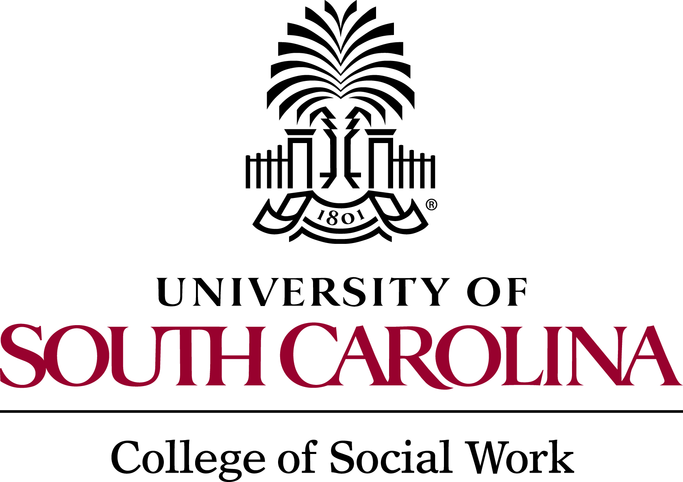
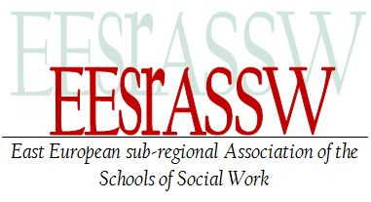

Conference
“International Social Work: Working Together for Success”
May 24-25, 2012, Petroşani

Schedule
Thursday, May 24, 2012 | Friday, May 25, 2012
9:00 – 9:30: Registration  9:30 – 9:45: Welcome, Opening Remarks  9:45 – 10:15: Lecture 1 (Keynote Speaker)  10:15 – 10:45: Lecture 2 (Keynote Speaker)  10:45 – 11:00: Coffee Break  11:00 – 11:50 : Volunteer Panel  11:50 – 12:20: Lecture 3  12:20 – 12:35: Lecture 4  12:35 – 13:35: Lunch Break  13:35 – 14:45: Workshops Round 1  14:45 – 15:45: Workshops Round 2  15:45 – 16:00: Coffee break  16:00 – 16:30: Lecture 5  16:30 – 17:30: Lecture 6 (Keynote Speaker)  17:30 – 18:15: Conclusions / Closing Remarks  18:30: Cultural Program Dinner at 3d Aqua | 9:45 -11:45: Field Visits to local NGOs – 2 Groups  - Caritas Organization  - Pollicino House Association  13:00 – 15:00: City Scavenger Hunt  15:00 – 15:30: Feedback and Conclusions  15:30 : Socialization - Time for participants
Conference
“International Social Work: Working Together for Success”
May 24 – 25, 2012, Petroşani

DAY 1
Thursday, May 24, 2012
9:00 – 9:30 |  | Registration (Conference Room at University of Petroşani Library)
9:30 – 9:45  Introduction/Opening Remarks |  | Aron Poantă, PhD, prof. univ. eng., Rector of the University of Petroşani
 |  | Vasile Ciocodeică, PhD, assoc. prof. univ., Director of the Socio-Human Department
 |  | Felicia Andrioni, PhD, lecturer univ., University of Petroşani
 |  | Darja Zavirsek, PhD, prof. univ., President of the Eastern European Sub-Regional Association of the Schools of Social Work of the IASSW
 |  | Karla Buru, MPH, Fulbright Student Researcher, University of South Carolina
9:45 – 10:15  Lecture 1 - Keynote Speaker |  | Lavinia Popp, PhD, lecturer univ., University “Eftimie Murgu” Reşiţa - Processes and progress in teenagers’ deviant dimension
10:15 – 10:45  Lecture 2 – Keynote Speaker |  | Jennifer Feenstra, PhD, associate prof. & Fulbright Scholar, Northwestern College – Volunteerism Worldwide
10:45 – 11:00 |  | Coffee break (Library Hall, first floor)
11:00 – 11:50 Volunteer Panel | 11:00-11:10 | Ilona Frank, German SOFIA Volunteer in Romania
11:00 – 11:50 Volunteer Panel | 11:10-11:20 | Zachariah Falconer-Stout, American Peace Corps Volunteer in Moldova
11:00 – 11:50 Volunteer Panel | 11:20-11:30 | Elma Loretta Morina, American Volunteer in Romania
11:00 – 11:50 Volunteer Panel | 11:30-11:40 | Nora Dubyk, Romanian Volunteer in Kenya
11:00 – 11:50 Volunteer Panel | 11:40 – 11:50 | Questions & Answers with the panel
11:50 – 12:20  Lecture 3 |  | Dana Bates, PhD Candidate, University of Wales, The Glory of God is Humanity Fully Alive: Eastern Orthodox in Dialogue with the Human Development Approach
12:20 – 12:35  Lecture 4 |  | Ion Hirghidus, PhD, lecturer univ., University of Petroşani - Social work ethics based on the categorical imperative and practical imperative
12:35 – 13:35 |  | Lunch Break (Library Hall, first floor)
13:35 – 14:45  Workshops Round 1 |  | Using Social Media for NGO Promotion – David Barker, Peace Corps Romania Volunteer (Lecture Room, first floor)
 |  | Music and Art Therapy Practices – Veronica Andreassen-Barker, MA, Peace Corps Romania Volunteer (Conference Room at University of Petroşani Library, first floor)
 |  | Using Creative Tools in Social Work – Felicia Andrioni, PhD, University of Petroşani & Lavinia Popp, PhD, “Eftimie Murgu” Reşiţa University (Blue Room, basement)
 |  | Public Health in Romania- Karla Buru, MPH, University of South Carolina, & Nora Dubyk, Caritas Organization (Periodical Room, first floor)
14:45 – 15:45  Workshops Round 2 |  | Using Social Media for NGO Promotion – David Barker, Peace Corps Romania Volunteer (Lecture Room, first floor)
 |  | Music and Art Therapy Practices – Veronica Andreassen-Barker, MA, Peace Corps Romania Volunteer (Conference Room at University of Petroşani Library, first floor)
 |  | Using Creative Tools in Social Work – Felicia Andrioni, PhD, University of Petroşani & Lavinia Popp, PhD, “Eftimie Murgu” Reşiţa University (Blue Room, basement)
 |  | Public Health in Romania- Karla Buru, MPH, University of South Carolina, & Nora Dubyk, Caritas Organization (Periodical Room, first floor)
15:45 – 16:00 |  | Coffee break (Library Hall, first floor)
16:00 – 16:30  Lecture 5 |  | Pippin Whitaker, PhD, assistant prof. University of South Carolina – Recognizing parallels and differences in international social work (via Skype)
16:30 – 17:30  Lecture 6 - Keynote Speaker |  | Camelia Măianu, MS prof., Harrisburg Area Community College, - Circle of Security: A Relationship-Based Intervention for Parents and Children
17:30 – 18:15 |  | Questions & Answers  Conclusions / Closing Remarks
18:30 |  | Cultural Program  Dinner at Restaurant 3d Aqua
Conference
“International Social Work: Working Together for Success”
May 24-25, 2012, Petroşani

DAY 2
Friday, May 25, 2012
9:45 -11:45  Field Visits to local NGOs – 2 Groups | 9:45-10:30  Group 1 | Visit to Caritas Organization: Karla Buru, Group 1
9:45 -11:45  Field Visits to local NGOs – 2 Groups | 10:45-11:30  Group 1 | Visit to Pollicino House Association: Karla Buru, Group 1
9:45 -11:45  Field Visits to local NGOs – 2 Groups | 10:00-10:45  Group 2 | Visit to Pollicino House Association: Felicia Andrioni, Group 2
9:45 -11:45  Field Visits to local NGOs – 2 Groups | 11:00-11:45  Group 2 | Visit to Caritas Organization: Felicia Andrioni, Group 2
13:00 – 15:00 |  | City Scavenger Hunt
15:00 – 15:30 |  | Feedback and Conclusions  (Conference Room at University of Petroşani Library)
15:30 |  | Socialization - Time for participants

